Lab - Gather System Information After an Incident
Additional Note: Yellow highlighted text indicates all of my answers.
(672021159)

Objectives
= Collect system information after an incident has occurred.
= View logs for potential intrusions.

Background / Scenario
When an incident occurs in an organization, the people responsible must know how to respond. An organization needs to develop an incident response plan and put together a Computer Security Incident Response Team (CSIRT) to manage the response. In this lab, you will gather system information and review logs after an incident has occurred. Doing these tasks immediately after the incident is important because any data residing in RAM will be gone when the system is shut down.

Required Resources
PC with the CSE-LABVM installed in VirtualBox
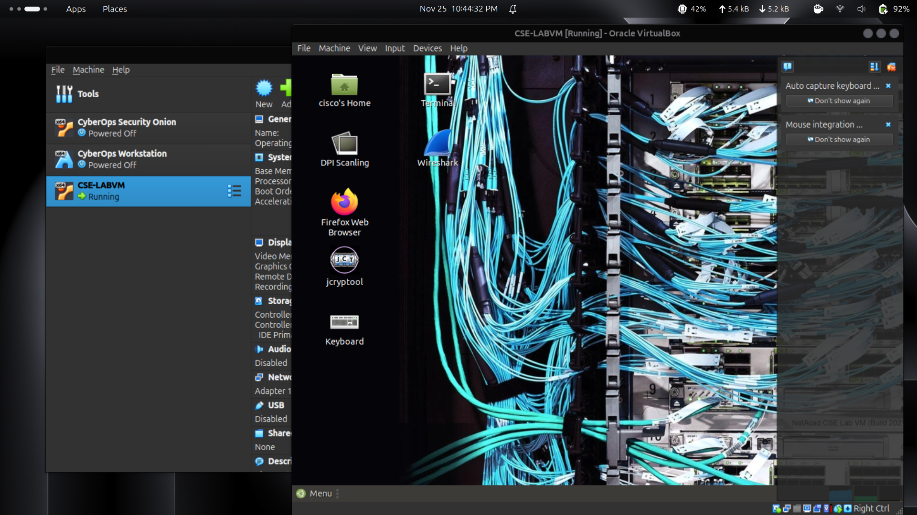

Instructions

Step 1: Open a terminal window in the CSE-LABVM.
a. Launch the CSE-LABVM.
b. Double-click the Terminal icon to open a terminal.

Step 2: Collect volatile information of the compromised system.
In this step, you will create a file called report.txt that includes a variety of system information that can be used for incident analysis. This report can then be transferred to a USB drive, emailed, or uploaded to a cloud server to preserve the information. Then the system can be taken down.
a. Switch to the root user with the sudo su command. Enter password as the root password.
cisco@labvm: ~$ sudo su
[sudo] password for cisco: password
root@labvm:/home/cisco#
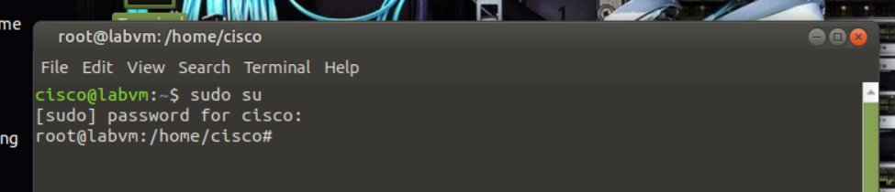
b. Enter the echo command, and then specify a heading for a newly created file named report.txt. Enter the cat command to review the new file.
root@labvm:/home/cisco# echo Incident Investigator Report > report.txt
root@labvm:/home/cisco# cat report.txt
Incident Investigator Report
root@labvm:/home/cisco#
c. Enter the date command and redirect the date and timestamp to the report.txt file. Be sure to use the double angle brackets (>>) to append to the report.txt file. Otherwise, you will replace the previous content.
Note: To better document the content stored in report.txt, use the echo command to add a subheading as shown here for Start Date and Time. Each substep will specify a subheading for you to append before you gather information.
root@labvm:/home/cisco# echo =====Start Date and Time===== >> report.txt
root@labvm:/home/cisco# date >> report.txt
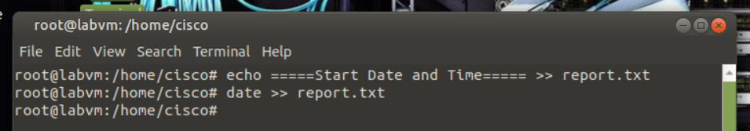
d. Enter the uname command to print system information. Use the -a option to append all system information to the report.txt file.
root@labvm:/home/cisco# echo =====System Information===== >> report.txt
root@labvm:/home/cisco# uname -a >> report.txt
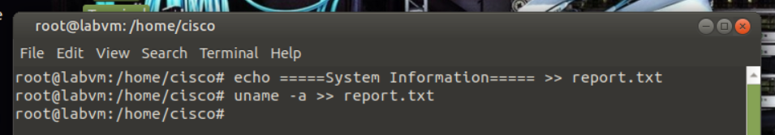
e. Enter the ifconfig -a command and append all network interface information to the report.txt file.
root@labvm:/home/cisco# echo =====Network Interfaces===== >> report.txt
root@labvm:/home/cisco# ifconfig -a >> report.txt
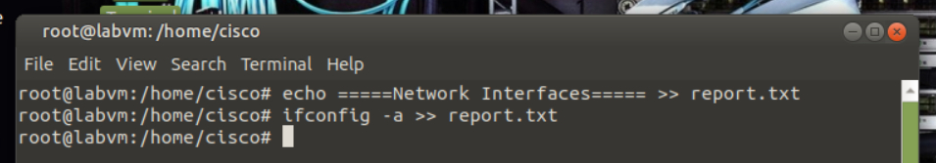
f. The netstat command can collect all the network statistics. Enter the command with the options -ano to collect data on all sockets (-a), IP addresses instead of domain names (-n), and information related to networking times (-o). Append the output to the report.txt file.
root@labvm:/home/cisco# echo =====Network Statistics===== >> report.txt
root@labvm:/home/cisco# netstat -ano >> report.txt
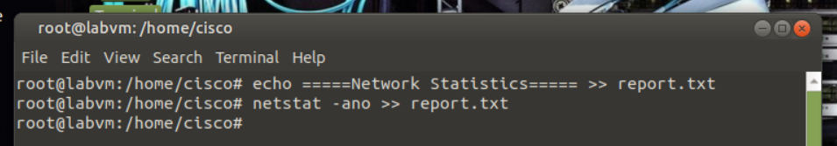
g. The ps command reports a snapshot of the current processes running on the system. Enter the command with the options -axu to list every process running on the system (-a and -x) and in a user-oriented format (-u). Append the output to the report.txt file.
root@labvm:/home/cisco# echo =====Processes===== >> report.txt
root@labvm:/home/cisco# ps axu >> report.txt
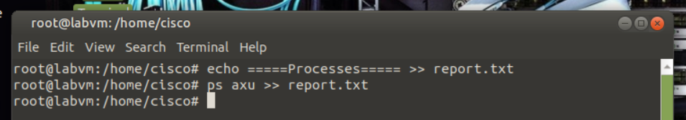
h. The route command lists the routing table currently used by the system. Enter the command with the option -n to list IP addresses instead of trying to determine host names. Append the output to the report.txt file.
root@labvm:/home/cisco# echo =====Routing Table===== >> report.txt
root@labvm:/home/cisco# route -n >> report.txt
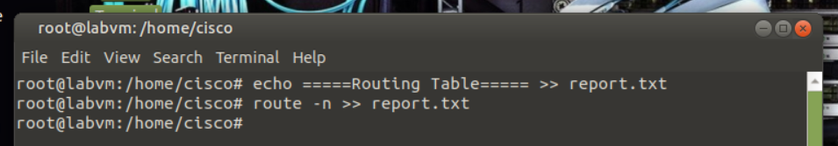
i. Enter the date command and append the date and timestamp to the end of the file to complete the report.
root@labvm:/home/cisco# echo =====End Date and Time===== >> report.txt
root@labvm:/home/cisco# date >> report.txt
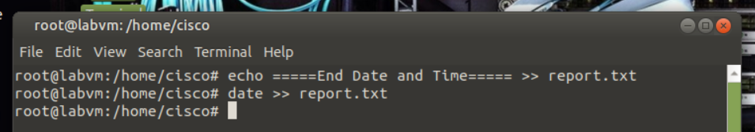
j. Use the cat command and pipe the output to the less command to view report.txt one page or line at a time. Press the spacebar to scroll down by page or press Enter to scroll down by a single line. Type q when finished.
root@labvm:/home/cisco# cat report.txt | less
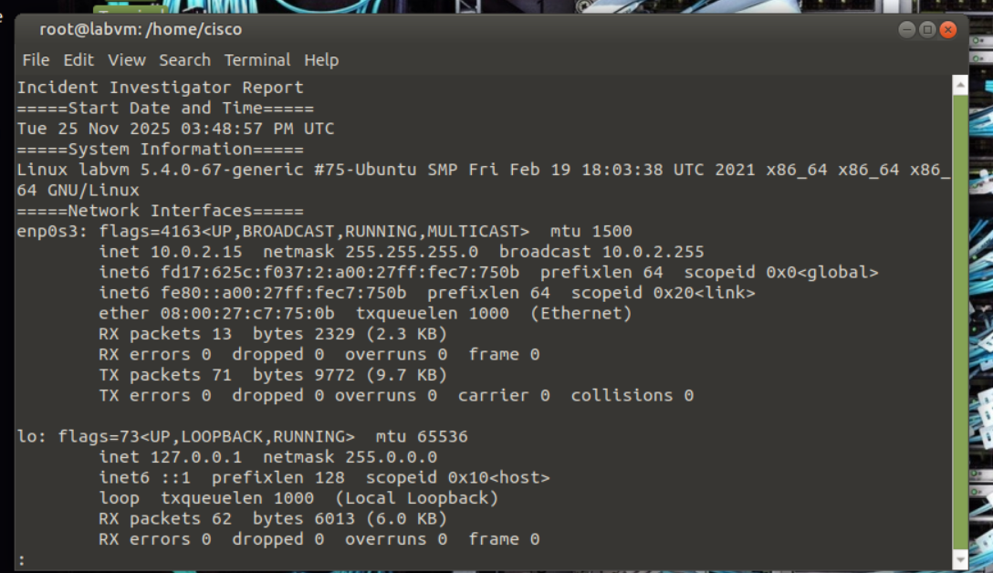
Incident Investigator Report
=====Start Date and Time=====
Wed 24 Mar 2021 05:06:53 PM UTC
=====System Information=====
Linux labvm 5.4.0-67-generic #75-Ubuntu SMP Fri Feb 19 18:03:38 UTC 2021 x86_64 x86_64 x86_64 GNU/Linux
=====Network Interfaces=====
enp0s3: flags=4163<UP, BROADCAST, RUNNING,MULTICAST> mtu 1500
inet 10.0.2.15 netmask 255.255.255.0 broadcast 10.0.2.255
inet6 fe80::a00:27ff:feb5:4bb0 prefixlen 64 scopeid 0x20<link>
ether 08:00:27:b5:4b:b0 txqueuelen 1000 (Ethernet)
RX packets 47719 bytes 36618515 (36.6 MB)
RX errors 0 dropped 0 overruns 0 frame 0
TX packets 31406 bytes 3590109 (3.5 MB)
TX errors 0 dropped 0 overruns 0 carrier 0 collisions 0

lo: flags=73<UP, LOOPBACK, RUNNING> mtu 65536
inet 127.0.0.1 netmask 255.0.0.0
inet6::1 prefixlen 128 scopeid 0x10<host>
loop txqueuelen 1000 (Local Loopback)
RX packets 2292 bytes 244651 (244.6 KB)
RX errors 0 dropped 0 overruns 0 frame 0
TX packets 2292 bytes 244651 (244.6 KB)
TX errors 0 dropped 0 overruns 0 carrier 0 collisions 0

=====Network Statistics=====
Active Internet connections (servers and established)
<output omitted>
unix 3 [ ] STREAM CONNECTED 22100
unix 3 [ ] STREAM CONNECTED 18249
=====Processes=====
USER PID %CPU %MEM VSZ RSS TTY STAT START TIME COMMAND
root 1 0.0 0.5 101896 10768? Ss Mar23 0:03 /sbin/init
root 2 0.0 0.0 0 0? S Mar23 0:00 [kthreadd]
root 3 0.0 0.0 0 0? I< Mar23 0:00 [rcu_gp]
<output omitted>
root 5319 0.0 0.0 0 0? I 16:31 0:00 [kworker/0:2-events]
root 5490 0.0 0.1 11492 3332 pts/1 R+ 17:06 0:00 ps axu
=====Routing Table=====
Kernel IP routing table
Destination Gateway Genmask Flags Metric Ref Use Iface
0.0.0.0 10.0.2.2 0.0.0.0 UG 100 0 0 enp0s3
10.0.2.0 0.0.0.0 255.255.255.0 U 0 0 0 enp0s3
10.0.2.2 0.0.0.0 255.255.255.255 UH 100 0 0 enp0s3
=====End Date and Time=====
Wed 24 Mar 2021 05:06:53 PM UTC
(END) q
root@labvm:/home/cisco#

Step 3: Analyze different log files and learn their importance.
In addition to capturing information stored in RAM, the system also maintains a variety of logs that you should review after an incident. These log files can also be appended to your report.txt file or stored separately off the system in the event the system needs to be wiped. Logs of particular interest include, but are not limited to, the following:
= auth.log - logs system authorization information
= btmp.log - logs failed login attempts
= wtmp.log - logs who is currently logged into the system
a. Use the cat command to view the auth.log and pipe it to the less command. Press the spacebar to scroll down by page or press Enter to scroll down by a single line. Type q when finished. Your output will be different.
root@labvm:/home/cisco# cat /var/log/auth.log | less
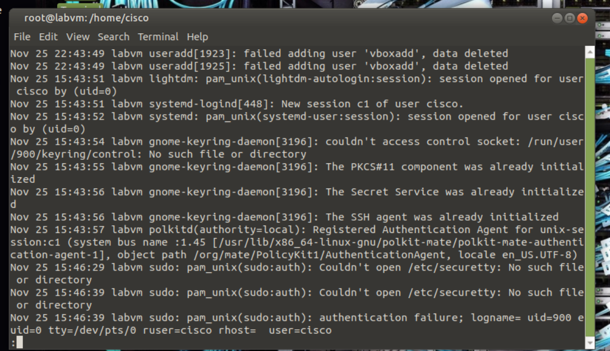
Mar 18 21:43:57 labvm sshd [375]: Server listening on 0.0.0.0 port 22.
Mar 18 21:43:57 labvm sshd [375]: Server listening on:: port 22.
Mar 18 21:43:57 labvm systemd-logind [366]: New seat seat0.
Mar 18 21:43:57 labvm systemd-logind [366]: Watching system buttons on /dev/input/event0 (Power Button)
Mar 18 21:43:57 labvm systemd-logind [366]: Watching system buttons on /dev/input/event1 (Sleep Button)
Mar 18 21:43:57 labvm systemd-logind [366]: Watching system buttons on /dev/input/event2 (AT Translated Set 2 keyboard)
Mar 18 21:43:59 labvm sshd [408]: error: kex_exchange_identification: Connection closed by remote host
Mar 18 21:43:59 labvm sshd [407]: Accepted password for cisco from 10.0.2.2 port 57067 ssh2
Mar 18 21:43:59 labvm sshd [407]: pam_unix(sshd:session): session opened for user cisco by (uid=0)
Mar 18 21:43:59 labvm systemd-logind [366]: New session 1 of user cisco.
<output omitted>
(END) q
root@labvm:/home/cisco#
b. The last command shows a listing of last logged in users. Enter the command with the -f option to specify the log file. The btmp log file shows failed login attempts. Your output will be different.
root@labvm:/home/cisco# last -f /var/log/btmp
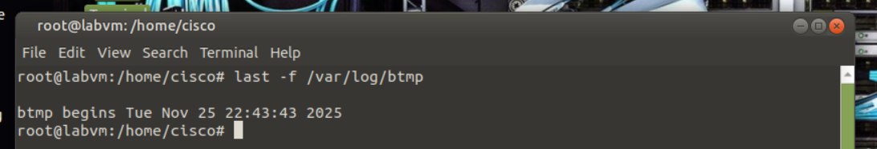
UNKNOWN tty6 Thu Mar 18 21:47 gone - no logout
UNKNOWN tty4 Thu Mar 18 21:47 gone - no logout
UNKNOWN tty3 Thu Mar 18 21:47 gone - no logout
cisco tty1 Thu Mar 18 21:47 gone - no logout
cisco tty1 Thu Mar 18 21:47 - 21:47 (00:00)

btmp begins Thu Mar 18 21:47:05 2021
root@labvm:/home/cisco#
c. Enter the last command again specifying the wtmp file to show who is currently connected to the system. Your output will be different.
root@labvm:/home/cisco# last -f /var/log/wtmp
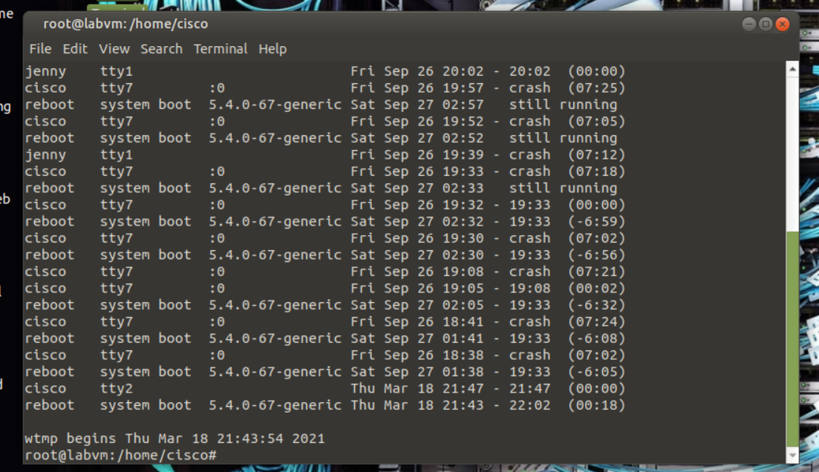
cisco tty7 :0 Tue Mar 23 19:38 gone - no logout
reboot system boot 5.4.0-67-generic Tue Mar 23 14:38 still running
cisco tty2 Thu Mar 18 21:47 - 21:47 (00:00)
reboot system boot 5.4.0-67-generic Thu Mar 18 21:43 - 22:02 (00:18)

wtmp begins Thu Mar 18 21:43:54 2021
d. Enter the exit command to switch back to the cisco user.
root@labvm:/home/cisco# exit
cisco@labvm: ~$
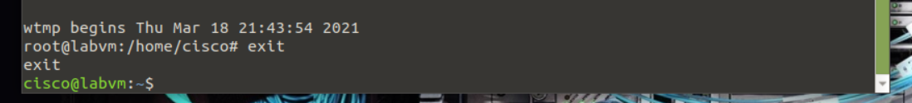
End of document

